İNANÇ MODEL UNITED NATIONS 2025
“CONTEMPLATING DIPLOMATIC FRACTURES WHILE BREAKING THE CYCLE OF SOCIOPOLITICAL INJUSTICE AND APATHY’’
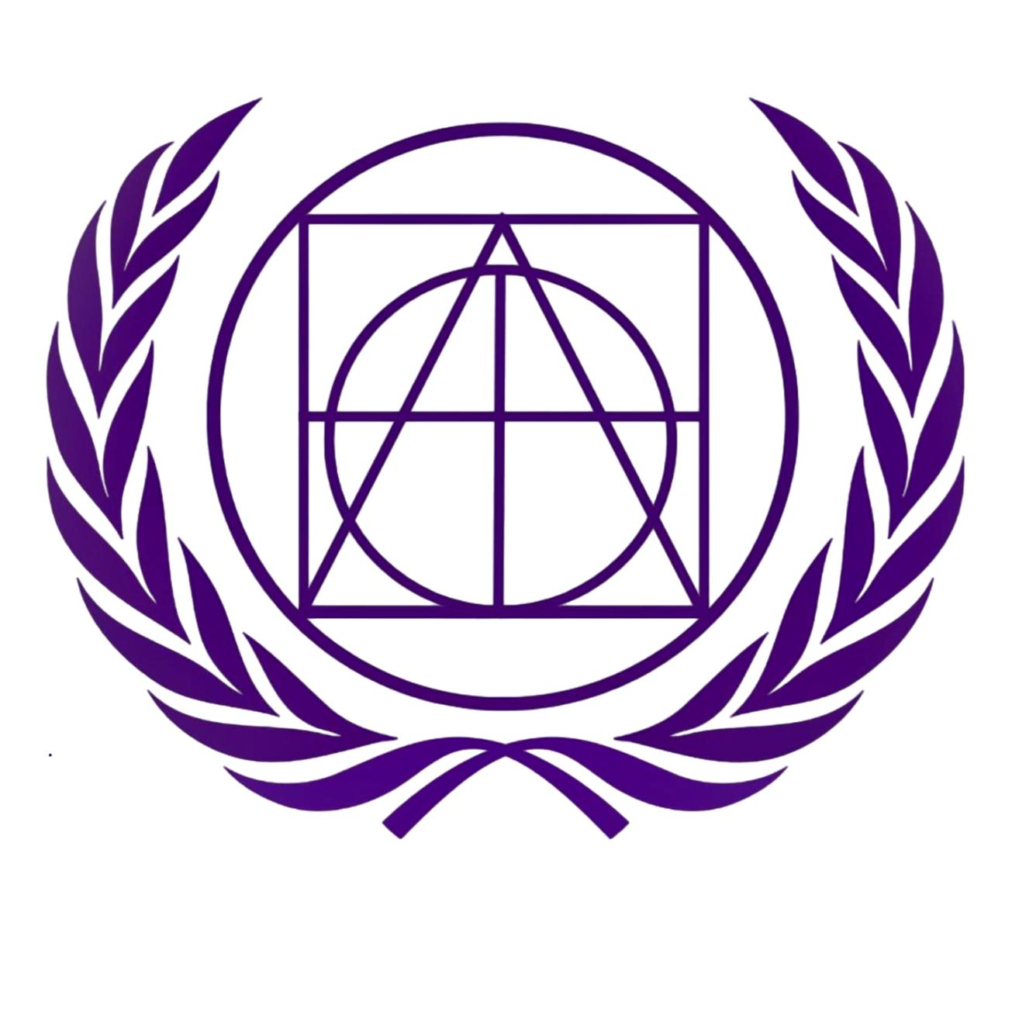Relieving Rising Tensions Between Regional Powers in the Horn of Africa
Yağız Eynur
Deputy Chair

Committee: GA1: DISEC
Issue: Relieving Rising Tensions Between Regional Powers in the Horn of Africa
Student Officer: Yağız Eynur
Position: Deputy Chair

Introduction
Horn of Africa is a region which is a strategic geography that has increasing unresolved political disputes and overlapping security crises. These problems about the area increased the risk of interstate escalation. The region’s instability is driven by interconnected factors: competition for maritime access and port influence, contested sovereignty and recognition disputes, cross-border involvement in internal conflicts, and the spillover of Sudan’s civil war. Recent diplomatic developments demonstrate both the seriousness of these tensions and the potential of mediation: the Ankara Declaration (11 December 2024) reaffirmed Ethiopia and Somalia’s commitment to sovereignty and territorial integrity and established a framework for further technical dialogue on sea access under Somalia’s sovereignty.
Nevertheless, diplomatic progress remains fragile. Regional institutions face challenges of unity and credibility, as shown by Eritrea’s withdrawal from IGAD amid renewed Ethiopia–Eritrea tensions and UN concern urging respect for territorial integrity and the Algiers framework. The committee is therefore tasked with exploring causes, identifying major actors and flashpoints, and proposing feasible confidence-building and security measures compatible with the UN Charter, the African Union’s Constitutive Act, and regional diplomacy.

Definition of Key Terms
Horn of Africa: A geopolitical region typically including Djibouti, Eritrea, Ethiopia, and Somalia, often discussed alongside Sudan/South Sudan due to security spillovers and shared strategic corridors.
Regional Power: A state with significant political, military, economic, or diplomatic influence within a region, shaping the security environment
Maritime Access: A state’s ability to reach and utilize ports, trade corridors, and maritime routes for economic and strategic purposes.
Confidence-Building Measures (CBMs): Practical steps (hotlines, transparency, joint commissions) designed to reduce miscalculation and build trust between rivals.
Sovereignty and Territorial Integrity: Fundamental principles of international law requiring respect for a state’s borders and political independence; central to disputes involving Somaliland and to commitments reaffirmed in the Ankara Declaration.
Ankara Declaration: A diplomatic framework announced on 11 December 2024 following talks facilitated by Türkiye between Ethiopia and Somalia. It reaffirmed the principles of sovereignty and territorial integrity and established a process for continued dialogue on Ethiopia’s access to the sea under Somalia’s sovereignty. The declaration aims to reduce tensions and prevent further escalation in the Horn of Africa.
General Overview

The Horn of Africa represents one of the most geopolitically sensitive and complex regions in Africa, marked by historical rivalries, colonial legacies, and overlapping territorial and political disputes. The strategic location of the Horn—adjacent to critical maritime corridors such as the Red Sea and the Gulf of Aden—renders it a pivotal area for regional and international security, economic trade, and humanitarian stability. Rising tensions among Ethiopia, Somalia, and Eritrea have not only local but also international implications, including threats to maritime security, refugee flows, disruption of trade routes, and the proliferation of armed non-state actors.
Ethiopia occupies a central position in the region, both in terms of population and military capacity. Its security posture is influenced by internal political dynamics, including federal-state relations, ethnic tensions, and recent conflicts such as those in Tigray. Beyond domestic stability, Ethiopia pursues long-term economic priorities, such as securing reliable maritime access for trade, particularly through engagement with Somaliland. The 2024 Memorandum of Understanding (MoU) with Somaliland sparked tensions with Somalia, highlighting the fragile balance between economic pragmatism and adherence to regional sovereignty norms. Ethiopia’s participation in frameworks like the Ankara Declaration demonstrates an awareness of the need for multilateral approaches and a willingness to negotiate arrangements that recognize Somalia’s sovereignty while protecting Ethiopian interests. Ethiopia’s engagement also intersects with UN efforts, particularly through UNDP programs supporting governance and economic infrastructure, which aim to reduce underlying tensions by strengthening institutional capacity.
Somalia, on the other hand, prioritizes sovereignty and territorial integrity, with particular sensitivity toward Somaliland’s political status. The Ankara Declaration process offered a diplomatic avenue to reaffirm Somalia’s territorial claims, enabling both confidence-building and technical negotiations with Ethiopia. Somalia’s cooperation with UNSOM (United Nations Assistance Mission in Somalia) and DPPA initiatives plays a critical role in supporting political reconciliation, security sector reform, and the development of administrative capacities at both federal and regional levels. Humanitarian actors, including OCHA, UNHCR, and IOM, address the consequences of internal displacement and conflict, ensuring that rising instability does not escalate into protracted humanitarian crises that could further destabilize the region.
Eritrea adds another layer of complexity to the Horn’s security environment. Its policies are strongly shaped by sovereignty concerns and its historical antagonism with Ethiopia. Eritrea’s withdrawal from IGAD (Intergovernmental Authority on Development) amid rising regional tensions is a significant development, limiting multilateral conflict-resolution avenues and affecting regional institutional cooperation. This withdrawal constrains efforts at mediation, as IGAD has traditionally provided a platform for dialogue, preventive diplomacy, and conflict monitoring. Eritrea’s strategic positioning near critical trade routes and borders also has implications for regional security, particularly regarding military deployments, border disputes, and involvement with non-state armed actors.
The African Union (AU) remains the principal continental mechanism for promoting “African-led solutions” to regional conflicts. Guided by the AU Constitutive Act, the AU employs preventive diplomacy, mediation, and peace support operations through its Peace and Security Council (PSC). The AU often coordinates with UN entities such as UNDP, DPPA, and the Peacebuilding Commission (PBC) to combine regional legitimacy with international resources and expertise. This cooperation ensures that interventions are both contextually informed and capable of addressing both immediate security concerns and long-term structural challenges.
Other UN actors contribute specialized roles that are critical to de-escalation and stabilization. UNHCR and IOM manage refugee flows and cross-border displacement, preventing humanitarian crises from exacerbating political tensions. UNDP and UNODC address governance gaps, rule of law, and illicit trafficking, which are increasingly intertwined with regional power disputes. OCHA facilitates coordination of humanitarian assistance, while Security Council resolutions often mandate monitoring, sanctions, and peacekeeping support to contain the influence of armed non-state actors. Collectively, these UN bodies create a multidimensional framework, combining political, humanitarian, and security interventions to relieve tension and promote sustainable peace.
Relieving rising tensions in the Horn of Africa thus requires a comprehensive, multi-layered approach, encompassing bilateral diplomacy, regional cooperation, African-led mediation frameworks, and targeted UN interventions. Historical grievances, sovereignty disputes, competition over economic resources, and humanitarian vulnerabilities must all be addressed in a coordinated manner. Sustaining regional stability depends not only on high-level political agreements but also on strengthening institutions, fostering inclusive economic development, and ensuring that international and regional mechanisms work synergistically. Only through such integrated engagement can help the Horn of Africa transition from a cycle of recurring tension to a framework of long-term peace, security, and development.

Major Parties Involved
Federal Democratic Republic of Ethiopia
Ethiopia is a central regional actor in the Horn of Africa whose security posture is shaped by persistent internal stability challenges, regional power dynamics, and long-term economic priorities. As a landlocked state, Ethiopia places strategic importance on securing reliable and diversified maritime access to support trade, economic growth, and national development. Its 2024 Memorandum of Understanding with Somaliland, which included provisions related to port access and security cooperation, significantly heightened diplomatic tensions with the Federal Republic of Somalia, as it was perceived as undermining Somalia’s sovereignty. However, Ethiopia’s later engagement in diplomacy through the Ankara Declaration framework signaled a partial recalibration of its approach, demonstrating a willingness to pursue negotiated arrangements that acknowledge Somalia’s territorial integrity while still safeguarding Ethiopia’s strategic economic and security interests.
Federal Republic of Somalia
Somalia has consistently prioritized the protection of its sovereignty, territorial integrity, and political unity, particularly with regard to the status of Somaliland. Any external engagement with Somaliland has been viewed by the Somali federal government as a direct challenge to these principles. Within this context, Somalia’s participation in the Ankara Declaration process was significant, as it reaffirmed international recognition of Somalia’s sovereignty while opening channels for dialogue aimed at de-escalation. The framework also established a basis for technical negotiations, allowing Somalia to pursue conflict management through diplomatic means rather than escalation, while strengthening its position within regional and international legal norms.
State of Eritrea
Eritrea’s security outlook is strongly shaped by concerns over national sovereignty, strategic autonomy, and its historically complex relationship with Ethiopia. While Eritrea has at times aligned with Ethiopia on regional security issues, underlying mistrust and shifting political dynamics continue to influence its foreign policy decisions. Eritrea’s withdrawal from the Intergovernmental Authority on Development (IGAD) amid rising regional tensions represents a significant development, as it weakens institutional mechanisms for dialogue, mediation, and collective security in the Horn of Africa. This decision has broader implications for regional cooperation, limiting the effectiveness of multilateral efforts to manage conflicts and reduce tensions among neighboring states.
African Union (AU)
The African Union plays a central role in shaping the region’s conflict management and security architecture through its Constitutive Act and related peace and security mechanisms. These frameworks emphasize principles such as respect for sovereignty, territorial integrity, and the peaceful resolution of disputes, forming the basis of the AU’s commitment to “African-led solutions to African problems.” Through tools including mediation, preventive diplomacy, early warning systems, and peace support operations, the AU provides both a legal and political platform for addressing regional crises. In the context of the Horn of Africa, the AU’s role is particularly important in facilitating dialogue, supporting de-escalation, and reinforcing continental norms against unilateral actions that risk destabilizing the region.

Timeline of Key Events
In this section, place the important events for the topic in the table in chronological order.

1991 | Eritrean Independence
1998–2000 | Eritrea-Ethiopia War
2006-2009 | Piracy Surge in the Gulf of Aden
2011 | Formation of UNSOM (United Nations Assistance Mission in Somalia)
2023 | Eritrea Withdraws from IGAD
2024 | Ethiopia-Somaliland MoU
2024 | Ankara Declaration Framework

Previous Attempts to Resolve the Issue
Multiple mechanisms have aimed to reduce tensions in the Horn of Africa. Regional diplomacy through IGAD and AU structures has traditionally supported dialogue and crisis management, while international partners often provide facilitation or technical support.
A notable recent attempt is the Ankara Declaration process, which placed emphasis on sovereignty, mutual respect, and continued technical dialogue—an approach consistent with de-escalation through structured negotiation rather than unilateral actions.
However, persistent mistrust, domestic political constraints, and competing threat perceptions have repeatedly limited implementation. Institutional strain—illustrated by Eritrea’s withdrawal from IGAD—can further weaken regional conflict-management capacity.

Possible Solutions
Relieving tensions in the Horn of Africa requires a coordinated, multi-dimensional approach in line with United Nations principles and mechanisms. Enhanced diplomatic engagement, facilitated by the UN Department of Political and Peacebuilding Affairs (DPPA) and the African Union Peace and Security Council, can provide structured dialogue, confidence-building measures, and technical negotiations to address sovereignty concerns and bilateral grievances. Strengthening regional security cooperation through IGAD and AU frameworks, along with UN-backed maritime security initiatives coordinated with UNODC and the International Maritime Organization, can prevent illegal arms trafficking, piracy, and other destabilizing activities. Governance and institution-building efforts, supported by UNDP, including security sector reform, transparent federal-regional coordination, and rule of law enhancements, can reduce internal vulnerabilities that often escalate into regional tensions. Humanitarian and development programs, coordinated by UNHCR, IOM, OCHA, and UNDP, can address the needs of refugees, internally displaced persons, and communities affected by conflict, while promoting inclusive economic growth and infrastructure development to mitigate competition over resources. Compliance with international law, monitored and supported by the UN Security Council and DPPA, ensures accountability, discourages unilateral military actions, and reinforces sovereignty principles. Finally, integrated peacebuilding strategies, including early warning systems and community-level reconciliation programs, can detect and address emerging conflicts before escalation, fostering sustainable stability. Collectively, these measures represent a UN-centered, comprehensive strategy aimed at de-escalating tensions and promoting long-term peace and development in the Horn of Africa.

Conclusion
The Horn of Africa remains one of the most geopolitically sensitive and complex regions in the world, where historical rivalries, territorial disputes, and competing economic and strategic interests intersect to create a fragile security environment. Rising tensions among Ethiopia, Somalia, and Eritrea have far-reaching consequences, not only for local populations but also for regional stability, maritime trade, and international security. These tensions exacerbate humanitarian crises, disrupt trade routes through the Red Sea and Gulf of Aden, and increase the risk of armed non-state actors exploiting political instability. Addressing these challenges requires a comprehensive and multi-dimensional strategy that integrates diplomacy, regional cooperation, institution-building, economic development, and humanitarian support, all grounded in adherence to international law and sovereignty principles.
The United Nations, in collaboration with the African Union, IGAD, and other regional stakeholders, provides the frameworks and mechanisms necessary to manage and de-escalate these tensions. Through mediation and preventive diplomacy facilitated by the UN Department of Political and Peacebuilding Affairs (DPPA) and the Peacebuilding Commission, coupled with AU Peace and Security Council initiatives, regional actors are encouraged to engage in structured dialogue, confidence-building measures, and technical negotiations. Complementary UN programs, such as UNDP-led governance and security sector reforms, and humanitarian assistance coordinated by UNHCR, IOM, and OCHA, address underlying structural challenges and mitigate the impact of displacement and conflict on vulnerable populations.
Ultimately, sustainable peace and stability in the Horn of Africa depend on the political will of regional actors to participate constructively within multilateral frameworks and respect internationally recognized norms. Effective coordination between the UN, regional institutions, and local governments can ensure early detection of potential conflicts, promote accountability, and foster inclusive development that reduces competition over resources. By combining preventive diplomacy, institution-building, and humanitarian support, the international community can help transform cycles of tension into opportunities for long-term cooperation, stability, and prosperity. The Horn of Africa, with its strategic location and critical role in regional trade and security, has the potential to become a model of multilateral engagement and African-led solutions, provided that sustained efforts are made to address both immediate conflicts and the structural drivers of instability.

Bibliography
Ayoob, Mohammed. The Horn of Africa: Regional conflict and super power involvement. Canberra: Strategic and Defence Studies Centre, Research School of Pacific Studies, Australian National University, 1978., 1978.
Kabandula, Abigail, and Timothy M. Shaw. "Rising powers and the horn of Africa: conflicting regionalisms." Rising powers in international conflict management. Routledge, 2020. 109-127.
Cliffe, Lionel. "Regional dimensions of conflict in the Horn of Africa." Third World Quarterly 20.1 (1999): 89-111.
Bereketeab, Redie. The Horn of Africa: intra-state and inter-state conflicts and security. Pluto Press, 2013.
Mengisteab, Kidane. Critical factors in the Horn of Africa's raging conflicts. Nordiska Afrikainstitutet, 2011.
Cliffe, Lionel, Roy Love, and Kjetil Tronvoll. "Conflict and peace in the Horn of Africa." Review of African Political Economy 36.120 (2009): 151-163.

