İNANÇ MODEL UNITED NATIONS 2025
“CONTEMPLATING DIPLOMATIC FRACTURES WHILE BREAKING THE CYCLE OF SOCIOPOLITICAL INJUSTICE AND APATHY’’
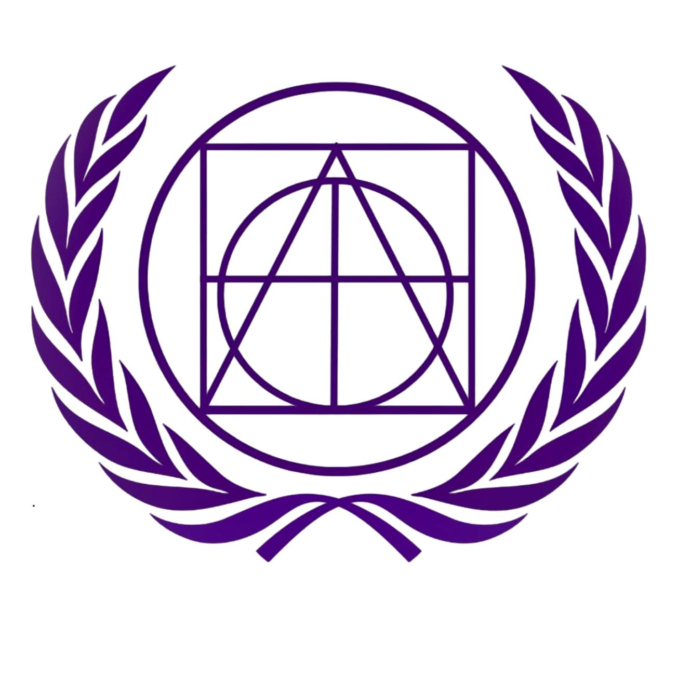
Resolving transboundary Nile disputes to secure regional prosperity

Duru Mazlum
President Chair

Committee: Economic and Financial Committee
Issue: Resolving transboundary Nile disputes to secure regional prosperity
Student Officer: Duru Mazlum
Position: President Chair

Introduction
The Nile River is one of the most important rivers in the world, especially since African Member States depend on it every day. It flows through many countries such as Sudan, Ethiopia, and Egypt. Many civilians depend on it for water, farming, and electricity. However, since the river is shared between many Member States, there are some conflicts between the Member States. This conflict causes tension and disagreement among the states, to which are called transboundary issues. If these issues are not resolved in a very small time frame, the regions end up in difficulties in states.
These disputes have come significantly heavier, especially due to the Grand Ethiopian Renaissance Dam (GERD) project. This conflict arose from Ethiopia, who wanted to create a dam in order to produce electricity to its citizens. However, Sudan and Egypt refused to allow this since they had doubts about their water supplies. Since Egypt’s area is mostly desert, and they have problems regarding the amount of water in their nations, even a small change of water can create big problems. This shows how sensitive the amount of water intake of the Nile is. Therefore; without the Member States cooperating together, these projects can turn into a dangerous political and economical scheme.
Solving the Nile disputes is not only about water, but also the future of the region. If the Member States are able to work together, the nations can have a huge improvement on their economical and financial status. Peaceful solutions will increase trust between nations and help them grow together instead of against each other. This is why solving the transboundary disputes on the Nile River can secure long-term peace and regional prosperity.

All headings should be written in size 15 this color and must be bold. All subheadings must be in this color in size 15 but not bold.

Definition of Key Terms
Transboundary Water: A water that flows through more than one country and must be shared between them.
Water Scarcity: A condition in which the demand for clean and usable water exceeds the available supply.
Downstream Countries: Countries that are located toward the end of a river’s flow and receive water after it has passed through upstream areas.
Upstream Countries: Countries that are located near the source of a river and control the initial flow of its water.
Grand Ethiopian Renaissance Dam (GERD): A large hydroelectric dam built on the Blue Nile in Ethiopia to generate electricity and support national development.
Water Security: The reliable availability of sufficient and safe water to meet the needs of people, agriculture, and industry.
Diplomacy: The practice of conducting negotiations and maintaining peaceful relations between countries.
Regional Prosperity: The condition in which multiple countries within a region experience economic growth, stability, and improved living standards.

General Overview
The Nile River and Its Regional Importance
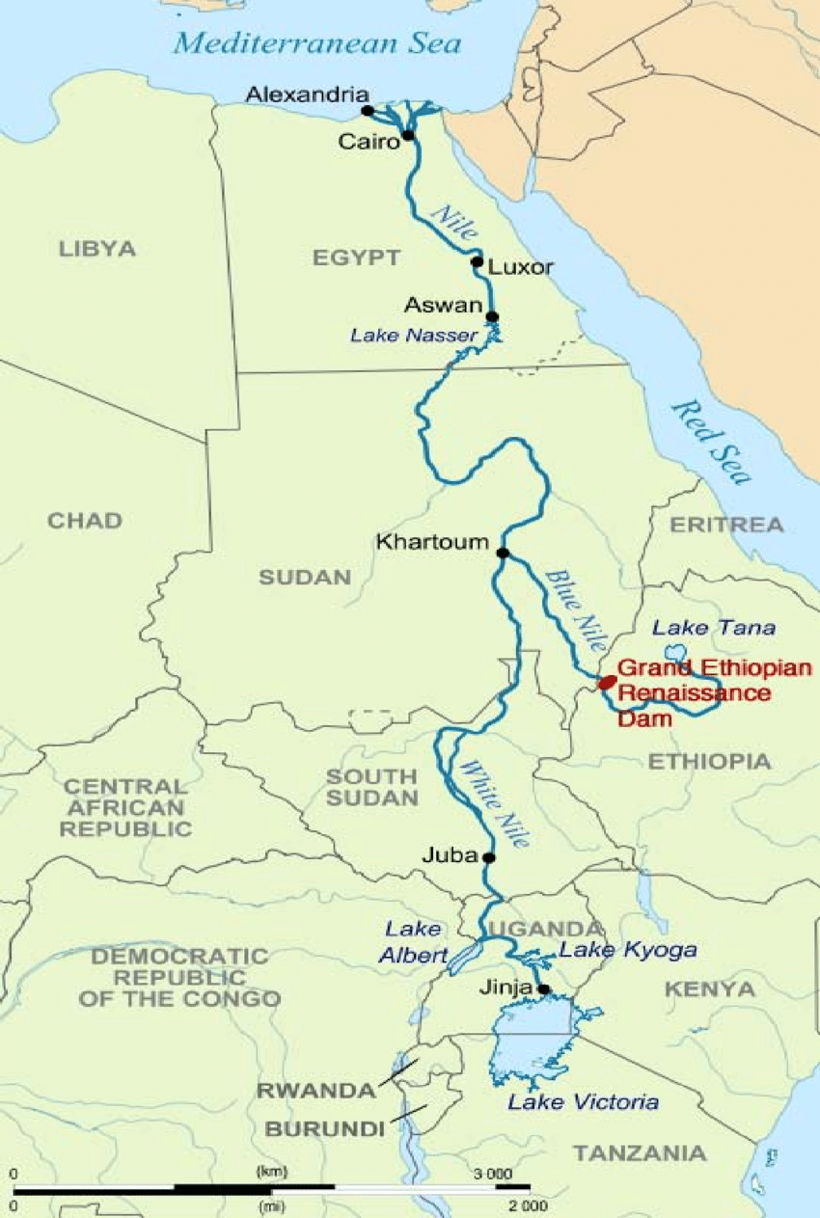
The Nile River is one of the most important rivers around the world, not only does it serve as a main source of water for millions, it also serves as a provider for transportation for trade and commerce in Northeastern Africa. The river flows through or directly affects eleven countries which are; Burundi, Rwanda, Tanzania, Uganda, Kenya, the Democratic Republic of Congo, South Sudan, Sudan, Ethiopia, Eritrea, and Egypt. For thousands of years, the civilians in Northeastern Africa have been counting on the Nile River for survival, agriculture, transportation and trade. Even today, the Nile is still the backbone of economic and social life in the region.
Egypt is the most dependent nation to the Nile river, as nearly %97 of its freshwater supplies comes from the river. Sudan is another nation who relies heavily on the river for farming and energy production. Ethiopia holds a strong geographical control over the Blue Nile, which is %85 of the water that eventually reaches Egypt. Since the river crosses many borders, it is classified as a transboundary river, which means that the Nile must be shared between nations. This shared river makes cooperation between nations necessary, but it also creates such political challenges.
With the population growing, climate changes, urbanization, and the rising water demand makes the Nile River more politically sensitive than ever. As nations are trying to develop their economies, they are naturally seeking more water for farming, industry, and electricity. However, when one nation increases its usage, other nations are likely to experience shortages. This tension lies at the heart of the Nile dispute.
Historical Background of the Nile River Disputes
The roots of the Nile dispute go back to the colonial period. In 1929 and later in 1959, water-sharing agreements were signed between Egypt and Sudan under British influence. These agreements gave Egypt the largest share of the Nile River’s water and a full veto power over upstream projects. Despite the fact, these agreements did not include other Nile Basin Member States such as Ethiopia, Uganda, or Kenya. This led to long term disagreements upon the treaty.
After upstream nations gained independence, they started to challenge these agreements. They argued that the treaties were unfair, outdated, and not enough to represent their interests. For a long time, these disagreements were solely political. However, when technology started to develop, the nations had more needs upon major water projects in order to strengthen their economies.
This shift from political disagreements to physical infrastructure development opened a new chapter for the Member States. The trans boundary issues on the Nile became a major factor for real world consequences. It affected water flow, energy production, and national security while increasing the fear of future water conflicts in the region.
The Grand Ethiopian Renaissance Dam (GERD) and Rising Tensions
The most significant recent development in the Nile is the construction of the Grand Ethiopian Renaissance Dam (GERD) by Ethiopia. This massive hydroelectric dam project started on April 2, 2011. It is located on the Blue Nile near the Sudanese border. Additionally, it is designed to be Africa’s largest hydroelectric power station and is expected to provide electricity for millions of Ethiopian citizens.
Ethiopia views this dam as an essential for economic and financial growth, although Egypt strongly disagrees with the project since it would reduce the amount of water reaching its territory. Because Egypt is a desert state, any reduction of the water level of the Nile would have a huge impact on its economical and social development.
Despite the fact, Sudan holds a more complex position. On one hand, Sudan has the possibility to benefit from the regulated water and get cheaper electricity. On the other hand, Sudan is aware of the fact that the dam might not be a safe and a long term project. The lack of a binding tripartite agreement between Ethiopia, Sudan, and Egypt has worsened the situation and increased distrust.
Therefore, negotiations have been still continuing with the involvement of international organizations such as the African Union and the United Nations. However, progress has been slow due to the differences in national interests and political pressures.
Water Security, Economic Impact, and International Water Law
Water security means having safe, reliable, and enough water to meet the daily needs of citizens, farming, and industry. Especially in the Nile Basin, water security is directly involved with the survival of Member States. Nations such as Egypt and Sudan are heavy reliers of the Nile for agriculture, drinking water, and electricity. Nearly all the fresh water in Egypt comes from the Nile, which makes the nation extremely dependent. If the water coming from the Nile decreases, there would be many economic crises happening. Similarly, Sudan has the same risk, since a large part of its citizens depend on the Nile for income.
At the same time, Ethiopia views the Nile as an enormous opportunity for economic growth. With large projects such as the GERD, Ethiopia aims to produce electricity for millions of citizens, and reduce poverty. Access to enough electricity would help out factories, healthcare, and regional trade. However, this would create a conflict. While Ethiopia would focus on the development of their nation, Sudan and Egypt would go on water survival mode. Since the Nile passes through all three nations, water security is the most important political and economic conflict upon those states.
International water law has a significant role on the balance of these competing interests. The most important principle is ‘equitable and reasonable utilization’, which basically means that all nations sharing a river have equal rights on the access of water. This principle is supported by the United Nations through the UN Watercourses Convention, which promotes peaceful cooperation and sustainable management of shared waters.
But the real issue in the dispute over the Nile is that countries have different interpretations of these legal principles. Egypt is a staunch proponent of historical water rights drawn from old conventions in 1929 and 1959 that allocated it the lion’s share of the Nile’s water. Ethiopia, however, insists that these deals are unfair and not in line with contemporary development requirements. Ethiopia is of the view that all Nile Basin countries should have equal rights to use the river for national development. Sudan stands between these two positions, supporting cooperation while demanding safety guarantees for security.

Major Parties Involved
Egypt
Egypt is one of the keen parties since it relies heavily on the freshwaters that come out of the Nile. The nation is skeptical that upstream projects, such as the GERD, may reduce the water flow coming to the nation. This reduction in water flow would likely threaten the agriculture, economic, and financial factors. Egypt stands on the idea that they have historical water rights from earlier treaties, and requests a legal binding agreement on water security.
Ethiopia
Ethiopia is the upstream nation who is currently in the process of establishing the Grand Ethiopian Renaissance Dam (GERD). Although Ethiopia argues that they have a right to use the Blue Nile to produce electricity for their nation, they are not aware of the political scheme they are creating. They believe that the past treaties were unfair due to the lack of Ethiopia’s presence in them. However, Ethiopia’s main approach was to have an equitable and reasonable use of shared waters.
Sudan
Sudan is both upstream and downstream of Ethiopia, giving it a complicated role. Sudan has a chance to benefit from the GERD by having a share of its stable water flow and electricity, but they also fear that the dam might not be a safe idea due to the risk of sudden changes in waters. Therefore, Sudan often poses in the middle of Egypt and Ethiopia, trying to balance cooperation between those nations.
African Union (AU)
The African Union plays as a safety net between the Member States on the GERD conflicts. The AU encourages African led solutions and supports a dialog between three major nations. Additionally, the AU has solved over 90% of the conflicts within the Nile territory. It is known that the AU’s involvement helps prevent tensions from escalating into open conflict.
United Nations (UN)
The United Nations supports the Nile dispute mainly through diplomacy and international law. It encourages peaceful negotiation and refers countries to the UN Watercourses Convention for fair water-sharing principles. The UN Security Council has discussed the issue during periods of high tension, urging dialogue. UN agencies also provide technical help on climate risks, sustainability, and data-sharing.
Timeline of Key Events
1923 - Nile Waters Agreement | Britain signs a treaty on behalf of its colonies, granting Egypt major control over the Nile and the right to veto upstream projects. Other upstream countries are excluded.
1959 – Egypt–Sudan Water Agreement | Britain signs a treaty on behalf of its colonies, granting Egypt major control over the Nile and the right to veto upstream projects. Other upstream countries are excluded.
1970s–1980s – Upstream Development  Plans Begin | Several upstream countries start discussing new water and irrigation projects, challenging Egypt’s dominance over the river.

1999 – Formation of the Nile Basin Initiative (NBI) | All Nile Basin states (except Eritrea) create the NBI to promote cooperation and shared development. It became the first major platform for joint water management.
2011 – Ethiopia Begins Construction of the GERD | Ethiopia starts building the Grand Ethiopian Renaissance Dam, transforming the political balance along the Nile. Egypt and Sudan express concern about the dam’s impact.
2015 – Declaration of Principles Signed | Egypt, Sudan, and Ethiopia sign a cooperative framework agreeing to negotiate dam filling and operation. However, many details remain unresolved.

2020 – First Filling of GERD | Ethiopia completes the first stage of filling the dam’s reservoir. Egypt and Sudan criticize the unilateral move, increasing tensions.
2021 – Second Filling of GERD | A second filling is completed without a final agreement, leading Egypt to warn of “existential threats” to its water security.
2023–2024 – Continued Diplomatic Stalemates | Multiple negotiation rounds fail to produce a final deal. All countries maintain strong national positions, and the dispute remains unresolved.

Previous Attempts to Resolve the Issue
Many different attempts have been made to solve the Nile conflict and the greatest number of these have lacked success because they are one-sided. The significance of the major early international documents include the agreement of 1929 and the agreement of 1959 that gave the Nile River's rights solely to Egypt and Sudan. This agreement ignored the countries within the Nile basin like Ethiopia and Kenya and Uganda. Further, the agreements occurred without involving the consultation of the upstream countries that later on repudiated the agreements for being old-fashioned and unjust.
To make the treaties even more comprehensive, the Nile Basin Initiative (NBI) agreement came into existence in 1999. The NBI was meant to serve as a process through which these nations could understand each other, and through NBI, the region of the Nile Basin could develop economically and environmentally. It was also ensured through the NBI that all nations share information related to water. However, these strong communications between nations did not lead to a water-sharing treaty.
The history of Nile Basin Initiative, to a large extent, relates to the significance of the treaties of 1929 and 1959, which not only concerned the transfer of absolute control of the Nile to Egypt and Sudan but also concerned the detachment of the western countries like Ethiopia and Kenya and Uganda from the Nile system. The countries disapproved of the treaties, as they regarded them as unjust and outdated. As such, they put the treaties into question.
The Nile Basin Initiative was launched in 1999 as the most important cooperative effort among several others for the establishment of consensus creation based on more cooperative approaches. The basic points of the Initiative pertained to the promotion of simultaneous mutual trust, development, as well as the distribution of water research-related data among the countries.

Possible Solutions
One​‍​‌‍​‍‌​‍​‌‍​‍‌ of the most powerful remedies would be the creation of a legally enforceable agreement between Egypt, Sudan, and Ethiopia on how to share water. Such a pact should carry very detailed and clear instructions on how the Nile water will be distributed, how the Grand Ethiopian Renaissance Dam (GERD) will be filled and operated, and, in general, what is the procedure in case of drought or emergency. What makes the problem worse is that most of the agreements signed in the past that are now being referred to are either outdated, loaded in favor of some countries, or they are not enforceable under law. A new contract grounded on international water law, particularly on the concepts of “equitable and reasonable use” and “no significant harm,”,would assure the parties security in the long run. It must also incorporate transparent data-sharing, open dialogue, and monitoring processes so that no country feels endangered or left out of significant decisions. The risk of conflict decreases if countries feel safe and respected, and at the same time, trust between them can be built gradually.
Regional cooperation can also be deepened through joint development projects that will bring benefits to all the Nile Basin countries and not only to one or two of them. What is the scenario of the future shared electrical grids between Ethiopia, Egypt, and Sudan? What about collaboration in agriculture, flood-control, or climate change adaptation? So instead of fighting for a piece of the scarce resource that is water, they are investing to water savings, irrigation-enhancing techniques, and energy production through hydropower. Besides that, the unified management of GERD is also an alternative, where the technical groups of the three countries oversee the dam's operations and ensure its safety and fairness. Not only does this path lessen political tension, but it also stimulates economic interdependence, which in turn makes the possibility of conflict lower since the countries start depending on each other for their mutual benefits. In the long run, regional cooperation has the potential to transform the Nile into a source of shared power rather than something that divides.
The last alternative is to have more international interventions and technical support. This is mostly from organizations like the African Union, the United Nations, and the World Bank. Such bodies can bring neutrals with the necessary skills to help the countries in analyzing water consumption, drought risks, dam safety issues, and the effects of climate change. The independent scientific research can go a long way to lessen the distrust factor among the countries since they all will have access to the exact and reliable data. Besides that, environmental planning becomes more and more imperative as the climate is changing and flowing in the Nile River will be less and less predictable. Countries are in need of shared early warning systems, drought- response strategies and long-run adaptation plans to secure their populations. The international partners will not only be able to facilitate the processes, but they can also do the financing of the systems in question, which will make them more effective. With international backing and the environment, a well-managed crisis of water scarcity in the region will be mitigated and there will be chances for building a future that is both sustainable and peaceful through cooperation rather than conflict. ​‍​‌‍​‍‌​‍​‌‍​‍‌

Conclusion
To​‍​‌‍​‍‌​‍​‌‍​‍‌ sum up, the Nile dispute is a clear example of how water, politics, and development are interlinked in the region. The conflicts between Egypt, Sudan, and Ethiopia depict the difficulties of sharing a single river that supports life among the countries that have different needs and levels of dependence. The past inequalities, the fear for national security, and the fast push to economic growth have all played a part in the current situation, in particular, the construction of the Grand Ethiopian Renaissance Dam.
Still, the dispute has, in turn, led to the important dialogue, diplomacy, and engagement of the region despite the challenges described above. These talks indicate that every country is aware of the necessity of finding a peaceful and collaborative way ahead before the matter escalates or becomes unpredictable. On the horizon, the main factor in solving the problem is the water-sharing set-up that is based on commitment, openness in negotiations, and methods of building trust which, in turn, create security for countries that will have access to the Nile in the future. The African Union and the United Nations are international institutions that may be of help in the implementation of the talks; however, the stamina to make a deal and to solve the problem rests on the countries.
An agreement to cooperate over the Nile River can turn the Nile River from a source of conflict into a shared engine of prosperity, providing sustainable energy, food security, and economic growth for millions of people. The destiny of the region is tied to the ways each country will demonstrate today, whether they are capable of changing a historical conflict into a basis of solidarity and of their lasting ​‍​‌‍​‍‌​‍​‌‍​‍‌stability.

Bibliography
Arsano, Yacob. Ethiopia and the Nile: Dilemmas of National and Regional Hydropolitics. University of Berne, 2007.
Cascão, Ana Elisa. “Ethiopia–Challenges to Egyptian Hegemony in the Nile Basin.” Water Policy, vol. 10, no. S2, 2008, pp. 13–28.
Hussein, Hussam. “Egypt’s Water Crisis and Degree of Influence over Its Transboundary Waters.” The International Spectator, vol. 54, no. 3, 2019, pp. 49–64.
International Crisis Group. Bridging the Gap in the Nile Waters Dispute. International Crisis Group, 2020.
Mekonnen, Daniel. “The Nile Basin Cooperative Framework Agreement Negotiations and the Adoption of a ‘Water Security’ Paradigm.” Goettingen Journal of International Law, vol. 2, 2010, pp. 283–313.
Salman, Salman M. A. “The Nile Basin Cooperative Framework Agreement: A Peacefully Unfolding African Spring?” Water International, vol. 38, no. 1, 2013, pp. 17–29.
Swain, Ashok. “Challenges for Water Sharing in the Nile Basin: Changing Geo-Politics and Changing Climate.” Hydrological Sciences Journal, vol. 56, no. 4, 2011, pp. 687–702.
Tvedt, Terje. The River Nile in the Age of the British: Political Ecology and the Quest for Economic Power. I.B. Tauris, 2016.
United Nations Economic Commission for Africa. Assessment of the Grand Ethiopian Renaissance Dam (GERD) and Opportunities for Cooperation in the Nile Basin. UNECA, 2017.
United Nations Environment Programme. Environmental Impact of Hydropower Development in the Nile Basin. UNEP, 2018.
Verhoeven, Harry. Water, Civilization and Power in Sudan: The Political Economy of Military-Islamist State Building. Cambridge University Press, 2015.
Wheeler, Kevin G., et al. “Understanding Cooperative and Noncooperative Outcomes in the Eastern Nile River Basin.” Water Resources Research, vol. 56, no. 4, 2020.
Yihdego, Zeray, Alistair Rieu-Clarke, and Ana Elisa Cascão. “The Grand Ethiopian Renaissance Dam and the Nile Basin: Implications for Transboundary Water Cooperation.” Journal of Water Law, vol. 24, 2019, pp. 1–12.
Institute for Security Studies. The AU’s Role Beyond the GERD Negotiations. Institute for Security Studies, 2020.
“Map Showing the Nile River with Its Main Branches.” ResearchGate, 2017.

